Muhammad Arif

Prof. Chuang

CISC 3140

March 13, 2021

Lab 5

Task 1

Which NYC boroughs rank first for the most shooting incidents?

Dataset: NYPD Shooting Incident Data (Year To Date)

<https://data.cityofnewyork.us/Public-Safety/NYPD-Shooting-Incident-Data-Year-To-Date-/5ucz-vwe8/data>

550 cd Desktop

551 cd Design\&Implementation/

552 mkdir l5

553 cd l5

554 git init

555 git remote add origin https://github.com/muhammadarif2113/CISC-3140.git

556 nano lab5Description.txt

557 git add lab5Description.txt

558 git commit -m "the fourth"

559 git push origin main

560 git push origin master

561 git branch -m master main

562 git push -u origin main

563 git push origin main

564 git pull origin main

565 git push origin main

566 history

567 ls

568 cat NYPD_Shooting_Incident_Data__Year_To_Date_.csv

569 ls

570 cat NYPD_Shooting_Incident_Data__Year_To_Date_.csv > lab5Description.txt

571 ls

572 xdg-open lab5Description.txt

573 ls

574 touch dataset-output.txt

575 cat NYPD_Shooting_Incident_Data__Year_To_Date_.csv > dataset-output.txt

576 ls

577 xdg-open dataset-output.txt

578 psql

579 sudo su -postgres

580*

581 sudo su -postgres

582 sudo su --postgres

583 sudo su – postgres

584 sudo su –postgres

585 psql

postgres=# CREATE DATABASE nycShootings WITH OWNER postgres

postgres=# \l

postgres=# \c nycshootings

nycshootings=# exit

postgres@moe-VirtualBox:~$ psql

postgres=# ALTER USER postgres WITH PASSWORD '**********';

postgres=# \c nycshootings

nycshootings=# \dt

nycshootings=# SELECT * FROM nypd_shooting_incident_data;

nycshootings=# SELECT boro, COUNT(*) FROM nypd_shooting_incident_data GROUP BY boro;

nycshootings=# \q

postgres@moe-VirtualBox:~$ exit

586 psql -d nycshootings -U postgres

587 cd Desktop

588 cd Design\&Implementation/

589 sudo su - postgres

590 ls

591 cd l5

592 ls

593 xdg-open dataset-output.txt

594 sudo su - postgres

595 echo "SELECT boro, COUNT(*) FROM nypd_shooting_incident_data GROUP BY boro" | sql nypd_shooting_incident_data > dataset-output.txt

596 sudo apt install parallel

597 echo "SELECT boro, COUNT(*) FROM nypd_shooting_incident_data GROUP BY boro" | sql nypd_shooting_incident_data > dataset-output.txt

598 ls

599 xdg-open dataset-output.txt

600 cat NYPD_Shooting_Incident_Data__Year_To_Date_.csv > dataset-output.txt

601 ls

602 touch solution-dataset.txt

603 ls

604 xdg-open solution-dataset.txt

605 git add dataset-output.txt solution-dataset.txt

606 git commit -m "new files uploaded"

607 git push origin master

608 git push origin master

609 git push origin main

610 git log

611 git push origin main

612 git pull

613 git push origin main

614 git push origin master

615 git push origin main

616 git pull master

617 git pull origin master

618 git push origin main

619 git pull origin master

620 git log

621 git branch -d master

622 git push origin --delete master

623 ls

624 git checkout main

625 git add dataset-output.txt lab5Description.txt NYPD_Shooting_Incident_Data__Year_To_Date_.csv solution-dataset.txt

626 git commit -m "all files added"

627 git push origin main

628 git pull

629 git init

630 git add dataset-output.txt lab5Description.txt NYPD_Shooting_Incident_Data__Year_To_Date_.csv solution-dataset.txt

631 git commit -m "final files"

632 git push origin main

633 git checkout main

634 git init

635 git push origin main

636 git branch --set-upstream-to=origin/<branch-name(main)> <branch-name(main)>

637 git push -f origin main

638 git log

639 git reset Head~1

640 git reset HEAD~1

641 LS

642 ls

643 xdg-open lab5Description.txt

644 nano lab5.docx

645 ls

646 git commit -m "lab5"

647 git add lab5.docx

648 git commit -m "lab5 docx"

649 git push origin main

650 git pull

651 git push origin main

652 git pull origin main

653 git commit -m "l"

654 git add lab5Description.txt NYPD_Shooting_Incident_Data__Year_To_Date_.csv

655 git commit -m "l"

656 git pull origin main

657 ls

658 git add lab5.docx

659 git commit -m "l5"

660 git pull origin main

661 git push origin main

662 ls

663 rm lab5Description.txt

664 ls

665 mv lab5.docx Lab 5 .doxc

666 mv lab5.docx Lab 5 .docx

667 mv lab5.docx Lab 5.docx

668 mv lab5.docx Lab5.docx

669 ls

670 git commit -m "5"

671 git rm lab5Description.txt

672 git add Lab 5 .docx

673 git add Lab5.docx

674 git commit -m "5"

675 git push origin main

676 history

677 sudo su – postgres

678 sudo su - postgres

679 history

Dataset: See dataset-output.txt

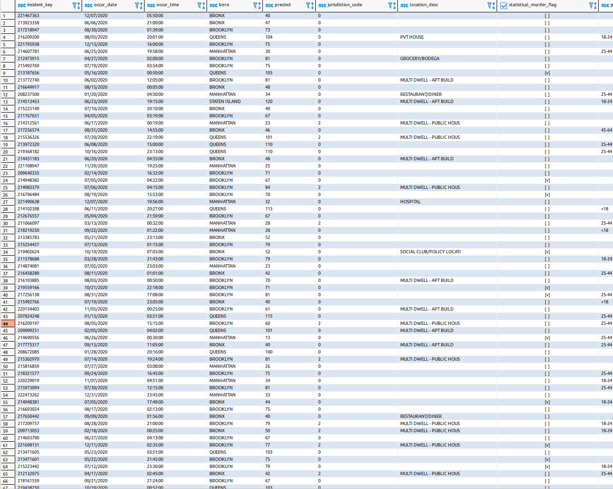

Solution: See solution-dataset.txt

